What is Project?

A project is a group of tasks that need to complete to reach a clear result. A project also defines as a set of inputs and outputs which are required to achieve a goal. Projects can vary from simple to difficult and can be operated by one person or a hundred.

Projects usually described and approved by a project manager or team executive. They go beyond their expectations and objects, and it's up to the team to handle logistics and complete the project on time. For good project development, some teams split the project into specific tasks so they can manage responsibility and utilize team strengths.

What is software project management?

**Software project management is an art and discipline of planning and supervising software projects. It is a sub-discipline of software project management in which software projects planned, implemented, monitored and controlled.**

It is a procedure of managing, allocating and timing resources to develop computer software that fulfills requirements.

In software Project Management, the client and the developers need to know the length, period and cost of the project.

### **Prerequisite of software project management?**

**There are three needs for software project management. These are:**

1. Time
2. Cost
3. Quality

It is an essential part of the software organization to deliver a quality product, keeping the cost within the client?s budget and deliver the project as per schedule. There are various factors, both external and internal, which may impact this triple factor. Any of three-factor can severely affect the other two.

## Project Manager

A project manager is a character who has the overall responsibility for the planning, design, execution, monitoring, controlling and closure of a project. A project manager represents an essential role in the achievement of the projects.

A project manager is a character who is responsible for giving decisions, both large and small projects. The project manager is used to manage the risk and minimize uncertainty. Every decision the project manager makes must directly profit their project.

### **Role of a Project Manager:**

**1. Leader**

A project manager must lead his team and should provide them direction to make them understand what is expected from all of them.

**2. Medium:**

The Project manager is a medium between his clients and his team. He must coordinate and transfer all the appropriate information from the clients to his team and report to the senior management.

**3. Mentor:**

He should be there to guide his team at each step and make sure that the team has an attachment. He provides a recommendation to his team and points them in the right direction.

### **Responsibilities of a Project Manager:**

1. Managing risks and issues.
2. Create the project team and assigns tasks to several team members.
3. Activity planning and sequencing.
4. Monitoring and reporting progress.
5. Modifies the project plan to deal with the situation.

Activities

Software Project Management consists of many activities, that includes planning of the project, deciding the scope of product, estimation of cost in different terms, scheduling of tasks, etc.

**The list of activities are as follows:**

1. Project planning and Tracking
2. Project Resource Management
3. Scope Management
4. Estimation Management
5. Project Risk Management
6. Scheduling Management
7. Project Communication Management
8. Configuration Management

## 

## Project Management Life Cycle

A project life cycle provides a high-level view of the project and the phases are tailored to fit a project’s needs providing a roadmap to accomplish it. The project management life cycle is divided into 5 phases: project initiation, planning, execution, monitoring & control, and closure.

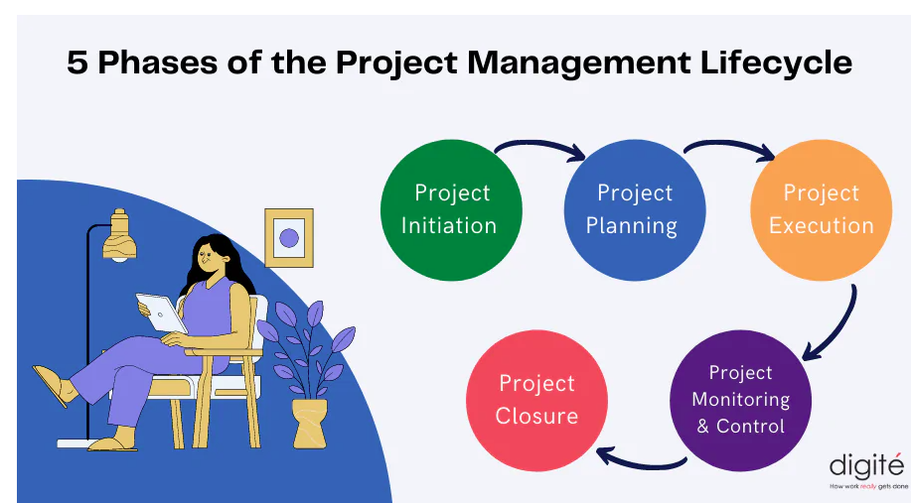

**1. Initiating**

In the initiation phase, you will define the project. You will sort out the project goals, scope, and resources of the project and what roles are needed on the team. Clarifying what stakeholders expect out of the project, and what exactly the project is aiming to achieve (and why) will give the project and team clear direction.

This is a crucial phase to the project’s success. Without clarity around what needs to be achieved and why the project runs the risk of not accomplishing the end results and meeting the expectations of stakeholders.

Some steps in the initiation phase include:

* Communicating with stakeholders to understand the purpose and desired outcomes of the project
* Identifying the scope of the project
* Determining SMART goals (specific, measurable, achievable, relevant, and time-bound)
* Clarifying resources like budget and time constraints
* Confirming team size and roles required
* Determining how often and which stakeholders will be involved throughout the project
* Compiling a project proposal and project charter

Tools and documents used in the initiation phase can include:

* Project proposal: The project proposal defines a project and outlines key dates, requirements, and goals.
* Project charter: This is a definitive document that describes the project and main details necessary to reach its goals. This can include potential risks, benefits, constraints, and key stakeholders.

**2. Planning**

In the planning phase, you will determine the steps to actually achieve the project goals—the “how” of completing a project.

You will establish budgets, timelines, milestones, source materials, and necessary documents. This step also involves calculating and predicting risk, establishing change processes in place, and outlining communication protocols. If the initiation phase is assembling your troops, the planning phase is deciding what to do with them.

The planning phase can include the following steps:

* Deciding on milestones that lead up to goal completion
* Developing a schedule for tasks and milestones, including time estimates and potential time buffers
* Establishing change processes
* Determining how and how often to communicate with team members and stakeholders
* Creating and signing documents such as non-disclosure agreements (NDAs) or requests for proposal (RFPs)
* Assessing and managing risk by creating a risk register
* Holding a kick-off meeting to start project

Tools you might use in a planning phase include:

Gantt chart: A horizontal bar chart in which members can see what tasks must be completed in which order and how long each task is expected to take

Risk register: A chart that lists risks associated with the project, along with their probability, potential impact, risk level, and mitigation plans

**3. Execute and complete tasks**

Executing a project means putting your plan into action and keeping the team on track. Generally, this means tracking and measuring progress, managing quality, mitigating risk, managing the budget, and using data to inform your decisions.

Specific steps might include:

* Using tools like GANTT or burndown charts to track progress on tasks
* Responding to risks when they manifest
* Recording costs
* Keeping team members motivated and on task
* Keeping stakeholders informed of progress
* Incorporating changes via change requests

Some tools you might use include:

* Change requests: These are documents used to propose changes to a project’s scope or goals
* Burndown chart: This chart breaks down tasks on a granular level and visualises the amount of time remaining

1. **Execution & Controlling**:

Monitoring and Controlling consists of those processes performed to observe project execution so that potential problems can be identified in a timely manner and corrective action can be taken, when necessary, to control the execution of the project.

The key benefit is that project performance is observed and measured regularly to identify variances from the project management plan.

Monitoring and Controlling includes:

• Measuring the ongoing project activities (where we are);

• Monitoring the project variables (cost, effort, scope, etc.) against the project management plan and the project performance baseline (where we should be);

• Identify corrective actions to address issues and risks properly (How can we get on track again);

• Influencing the factors that could circumvent integrated change control so only approved changes are implemented

**5. Close project**

In the closing phase of the project management lifecycle, you will conclude project activities, turn the finished product or service over to its new owners and assess the things that went well and did not go so well. It will also be a time to celebrate your hard work.

Steps in the closing phase can include:

* Conducting retrospectives and take notes of changes you can implement in the future
* Communicating to stakeholders at the end of the project and providing an impact report
* Communicating with the new owners of a project
* Creating a project closeout report
* Celebrating the end of the project and your successes

Tools used in the closing phase include:

* Impact report: This report compiles a series of metrics that showcase how your project made a difference and is presented to your stakeholders.
* Project closeout report: A project closeout report provides a summary of your project’s accomplishments, and provides key learnings for future project managers to reference.

**4P’s of project management**

your project can help your team meet its goals and objectives. The four P’s are :

1. People

2. Product

3. Process

4. Project

**People**

Identifying the roles people play in almost any given project is the first step to a successful project. People are the primary resource on every project, and a well-managed team can greatly increase the chances for success. Some of the different

roles people play in project management includes project manager, project team members, sponsors, stakeholders, business analysts and information technology developers.

**Product**

As the name implies, this is the deliverable of the project. The project manager should define the product scope to ensure a successful outcome, control “scope creep”; as well as technical hurdles that he or she may encounter.

With that said, the product does not necessarily need to be restricted to software; project management can be applied to all industries with software development being one of the key elements. The product of a project can also be something that is intangible; such as moving a company to a new headquarters or setting up a new company as a registered legal entity to commence trading activities on day one.

**Process**

The third P of project management is Process. Project managers and team members should have a methodology and plan that outlines their approach. Without a clearly defined process, team members will not know what to do and when to carry out project activities. However, this problem can be avoided through comprehensive early stage process planning. Using the right process will increase the project execution success rate that meets its original goals and objectives.

**Project**

The fourth and final P of project management is Project. This is where the project manager’s roles and responsibilities come into play. He or she must guide team members to achieve the project’s goals and objectives. The project manager must delegate tasks, help team members when needed, and ultimately strive to accomplish all requirements set forth in the project scope.

Hopefully, this gives you a better understanding of the four P’s of project management. To recap, it consists of People, Product, Process and Project. Without these four elements, project planning and execution will be impacted with roadblock issues and are less likley to meet their original goals.

# W5HH Principle

The W5HH principle in software management exists to help project managers guide objectives, timelines, responsibilities, management styles, and resources.

W5HH questions :

**Why the system is going to be developed?**

For the purpose of software work, all stakeholders must assess the validity of the system product/project. Here Barry questions that whether the project’s purpose will justify the cost, time spent on it by people?

**What is activities are needed to be done in this?**   
In this Barry questions what task is needed to be done for a project currently.

**When is this done?**   
Project Scheduling is done by the team after recognizing when project tasks will be started and when they enter into the final stage to reach the goal.

**Who are the reasons for these activities in this project?**  
Every member who is part of the software team is responsible for this. And their roles are defined.

**Where are these authoritatively located?**   
Not only do software practitioners have roles in this but also users, customers, stakeholders also have roles and responsibilities organizationally.

**How is**the **job technically and managerially finished?**   
All technical strategies, management rules of the project are defined after knowing the scope of the project which is being built.

**How much part of each resource is required?**   
This is known by software developers after the estimation of each resource as per the needs of customers/users.

This W5HH principle of Bohem is appropriate irrespective of the scale or difficulty of software projects being developed. These questions help in planning the outline of the project for the software team.

The **W5HH principle** outlines a series of questions that can help project managers more efficiently manage software projects. Each letter in W5HH stands for a question in the series of questions to help a project manager lead. (Notice there are five ”W” questions and two ”H” questions).